Trace Stewart

CPE301 – SPRING 2018

Design Assignment X

**DO NOT REMOVE THIS PAGE DURING SUBMISSION:**

The student understands that all required components should be submitted in complete for grading of this assignment.

|  |  |  |  |
| --- | --- | --- | --- |
| **NO** | **SUBMISSION ITEM** | **COMPLETED (Y/N)** | **MARKS**  **(/MAX)** |
| 1 | COMPONENTS LIST AND CONNECTION BLOCK DIAGRAM w/ PINS |  |  |
| 2. | INITIAL CODE OF TASK 1/A |  |  |
| 3. | INCREMENTAL / DIFFERENTIAL CODE OF TASK 2/B |  |  |
| 3. | INCREMENTAL / DIFFERENTIAL CODE OF TASK 3/C |  |  |
| 3. | INCREMENTAL / DIFFERENTIAL CODE OF TASK 4/D |  |  |
| 3. | INCREMENTAL / DIFFERENTIAL CODE OF TASK 5/E |  |  |
| 4. | SCHEMATICS |  |  |
| 5. | SCREENSHOTS OF EACH TASK OUTPUT |  |  |
| 5. | SCREENSHOT OF EACH DEMO |  |  |
| 6. | VIDEO LINKS OF EACH DEMO |  |  |
| 7. | GOOGLECODE LINK OF THE DA |  |  |
|  |  |  |  |
|  |  |  |  |

1. **COMPONENTS LIST AND CONNECTION BLOCK DIAGRAM w/ PINS**

The components used for the assignment were the Atemga Xplained mini and the LM34 Temperature Sensor along with a micro usb cable to connect the mini to the computer.

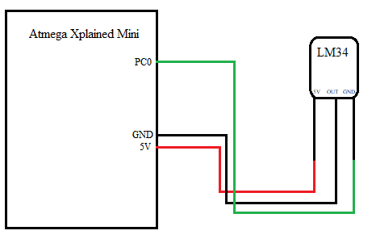

1. **INITIAL/DEVELOPED CODE OF TASK 1**

/*

* DA3.c

*

* Created: 3/18/2018 12:33:30 PM

* Author : trace

*/

#include <avr/io.h>

#include <avr/interrupt.h>

#define *F_CPU* 16000000L

#include <util/delay.h>

#include <stdlib.h>

#define BAUD 9600

volatile int ovrflw; // global variable for keeping track of # of times Timer0 overflows

// functions

void initUART();

void writeChar(unsigned char c);

void writestring(char *c);

int main(void){

initUART(); // Initialize UART

// initialize ADC

DDRC = 0; // Set PORTC as input for adc

DIDR0 = 0x1; // Disable digital input on ADC0 pin

ADMUX = 0; // ADC0 (PC.0) used as analog input

ADMUX |= (1 << REFS0); // use AVcc as the reference

ADMUX |= (1 << ADLAR); // Right adjust for 8 bit resolution

ADCSRA = 0x87; // Enable ADC, system clock, 10000111

ADCSRB = 0x0; // Free running mode

// initialize timer0 with starting value of 0, normal mode with no pre scaler

TCNT0 = 0;

TCCR0A = 0;

TCCR0B |= 2;

// enable interrupts

TIMSK0 |= (1 << TOIE0); // enable overflow interrupt

sei(); // enable global interrupts

while (1);

return 0;

}

void initUART() {

unsigned int baudrate;

// Set baud rate: UBRR = [F_CPU/(16*BAUD)] -1

baudrate = ((*F_CPU*/16)/BAUD) - 1;

UBRR0H = (unsigned char) (baudrate >> 8);

UBRR0L = (unsigned char) baudrate;

UCSR0B |= (1 << RXEN0) | (1 << TXEN0); // Enable receiver and transmitter

UCSR0C |= (1 << UCSZ01) | (1 << UCSZ00); // Set data frame: 8 data bits, 1 stop bit, no parity

}

void writeChar(unsigned char c) {

UDR0 = c; // Display character on serial (i.e., PuTTY) terminal

*_delay_ms*(10); // delay for 10 ms between each letter

}

void writestring(char *c){

unsigned int i = 0;

while(c[i] != 0)

writeChar(c[i++]);

}

// this interrupt service routine (ISR) runs whenever an overflow on Timer0 occurs

ISR (TIMER0_OVF_vect) {

// Variable Declarations

char output[6]; // Output string based on ADC

char *label = "Temperature: " + '\0'; // Temperature String

char *unit = " F" + '\0'; // Degree String

unsigned int adcVal; // 8-bit ADC value

float temperature; // Voltage received by ADC then edited for Temperature

if (ovrflw == 7500) {

ADCSRA |= (1 << ADSC); // Start conversion

while((ADCSRA&(1<<ADIF))==0); // Wait for conversion to finish

adcVal = ADCH * 9 / 5; // Only need to read the high value for 8 bit then equation for Fahrenheit

temperature = adcVal; // Temperature

*dtostrf*(temperature, 4, 1, output); // Float to char* conversion

// Print temperature to the terminal using UART

writestring(label);

writestring(output);

writestring(unit);

// Print end of line

writeChar('\n');

writeChar('\r');

ovrflw = 0; // reinitialize ovrflw

}

else

ovrflw++; // increment ovrflw

}

1. **TASK 2**

//This is what I changed in the above program to get the results from the data visualizer.

void writeChar(float c);

…

void writeChar(float c) {

UDR0 = c; // Display character on serial (i.e., PuTTY) terminal

*_delay_ms*(10); // delay for 200 ms

}

/*

void writestring(char *c){

unsigned int i = 0;

while(c[i] != 0)

writeChar(c[i++]);

}

*/

…

writeChar(temperature);

// Print temperature to the terminal using UART

/*writestring(label);

writestring(output);

writestring(unit);

// Print end of line

writeChar('\n');

writeChar('\r');*/

1. **SCHEMATICS**

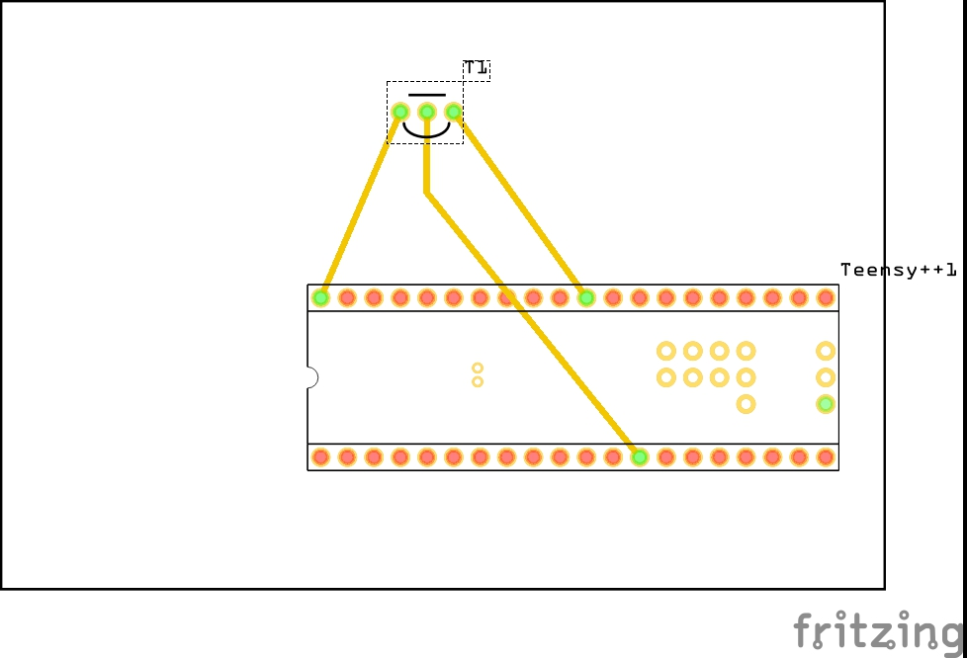

1. **SCREENSHOTS OF EACH TASK OUTPUT (ATMEL STUDIO OUTPUT)**

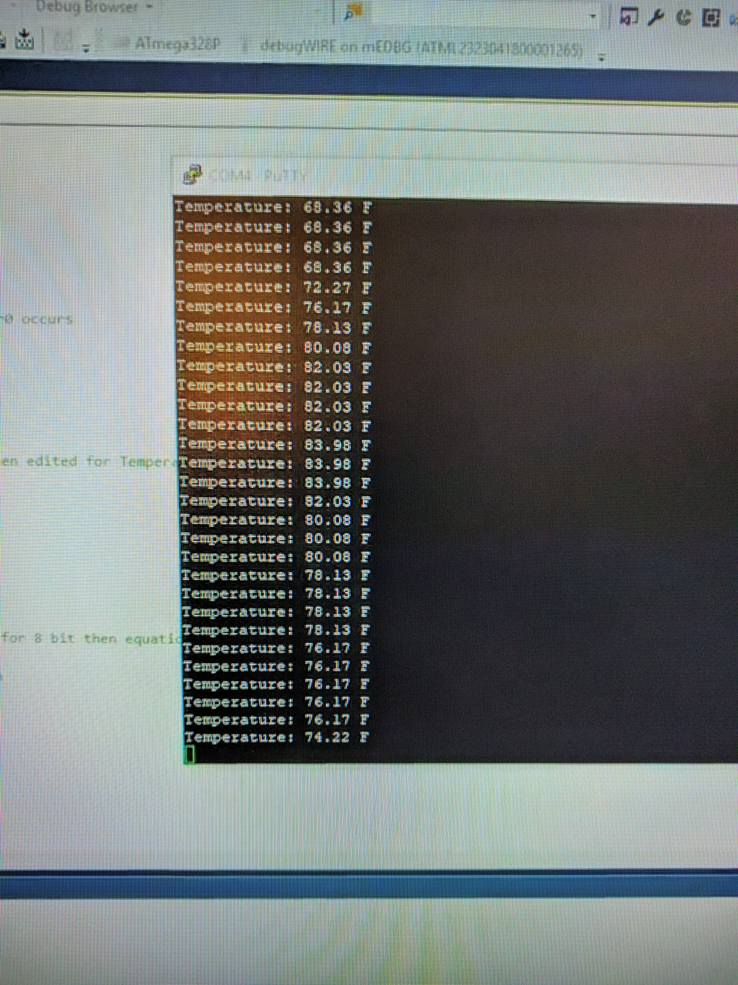

Figure : Temperature Increasing after holding onto the sensor (Putty)

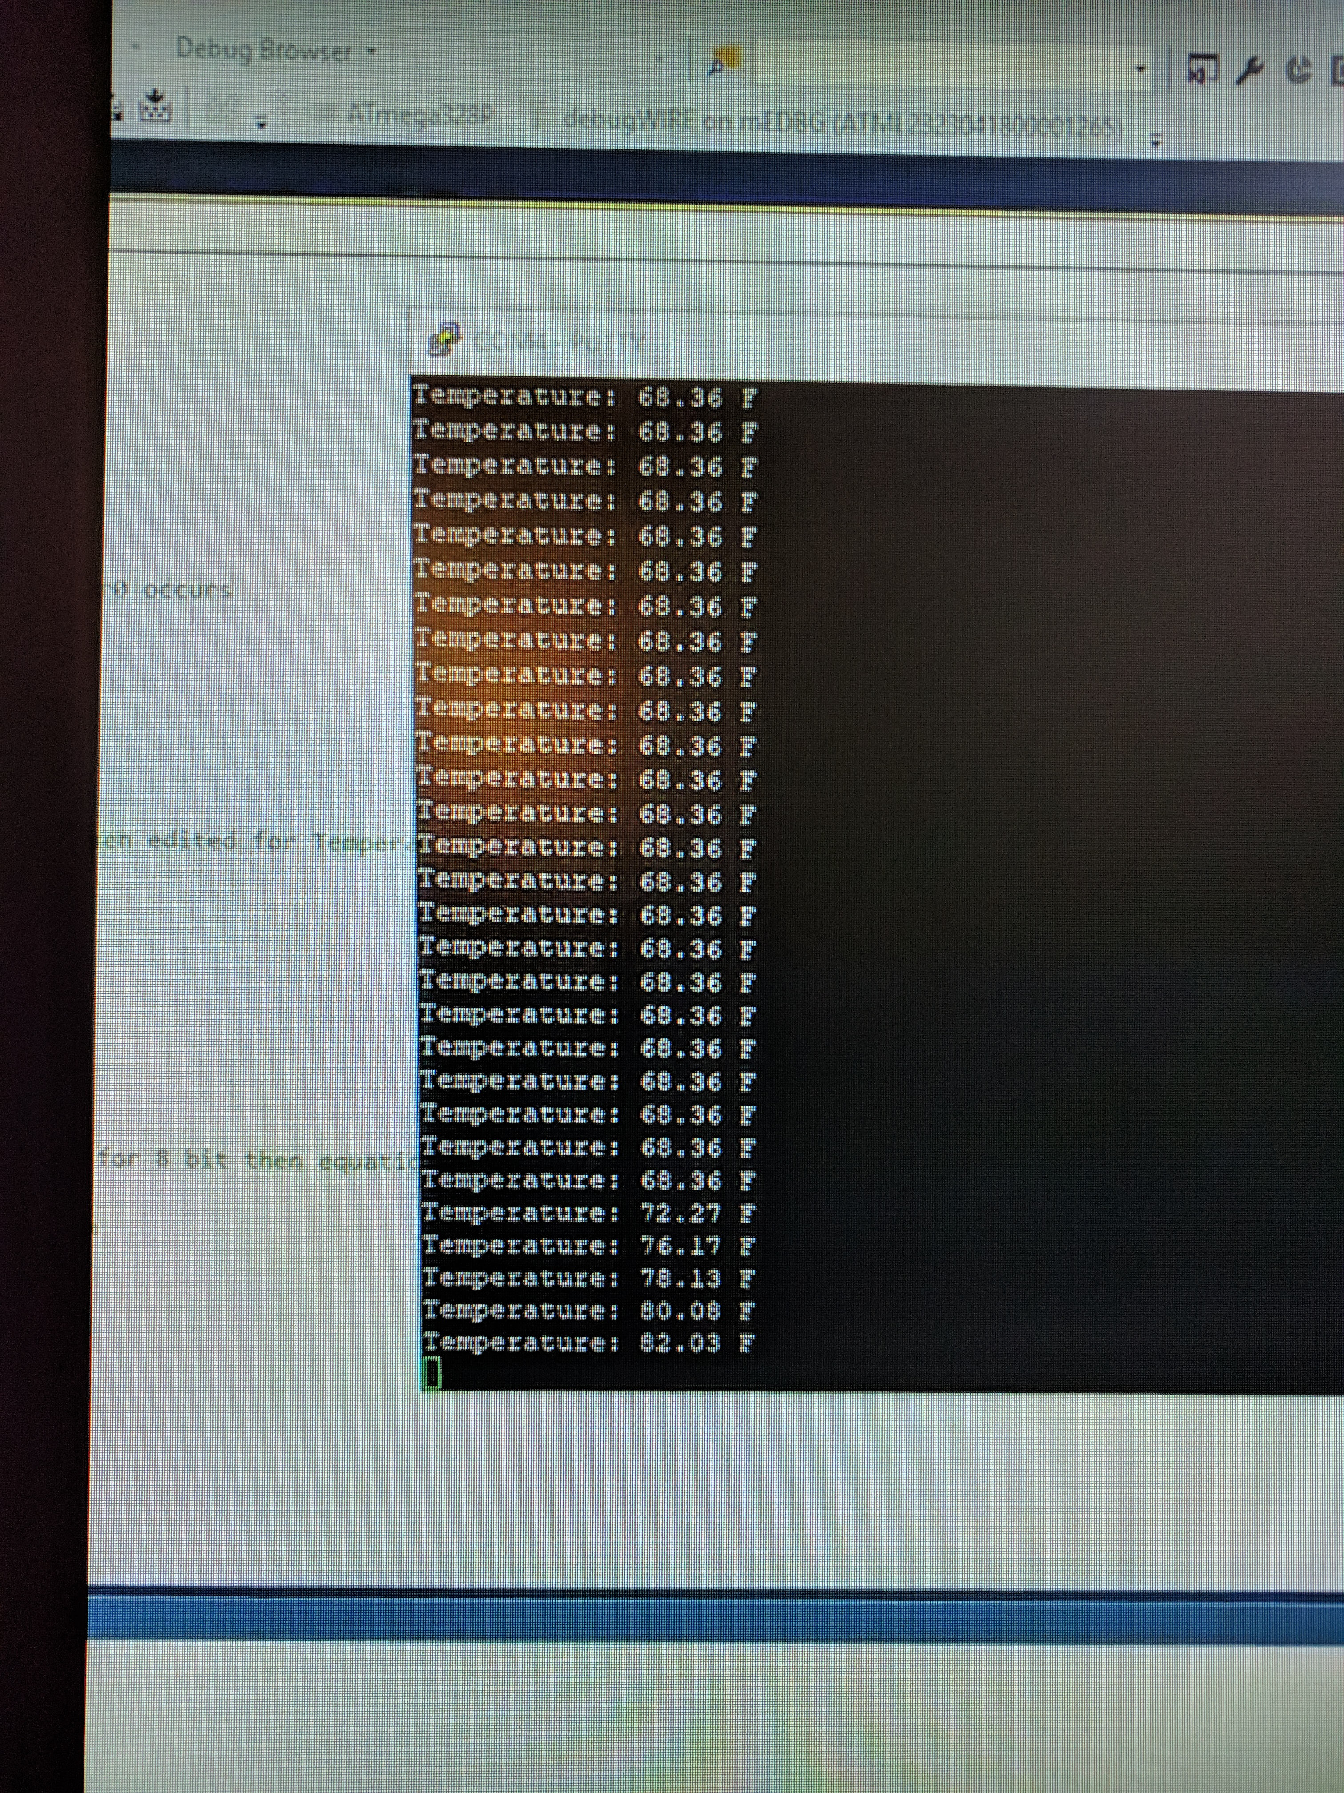

Figure 2: The temperature decreasing after letting go of the sensor (Putty)

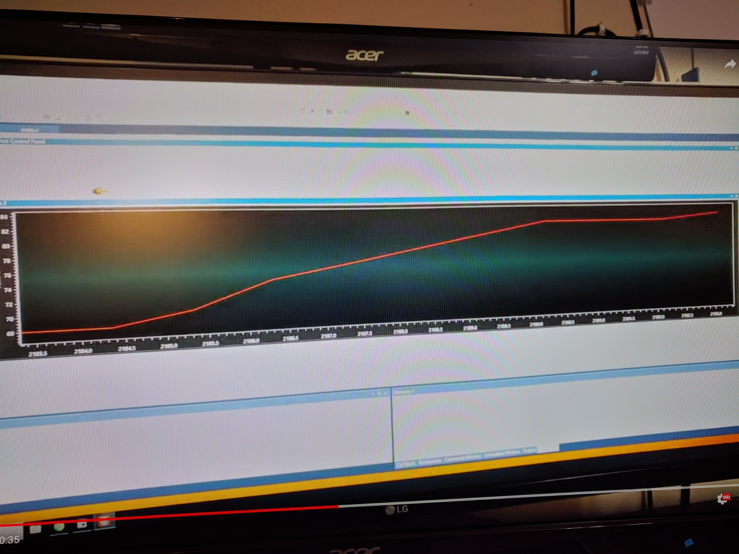

Figure :Temperature Increasing after holding onto the sensor (Data Visualizer)

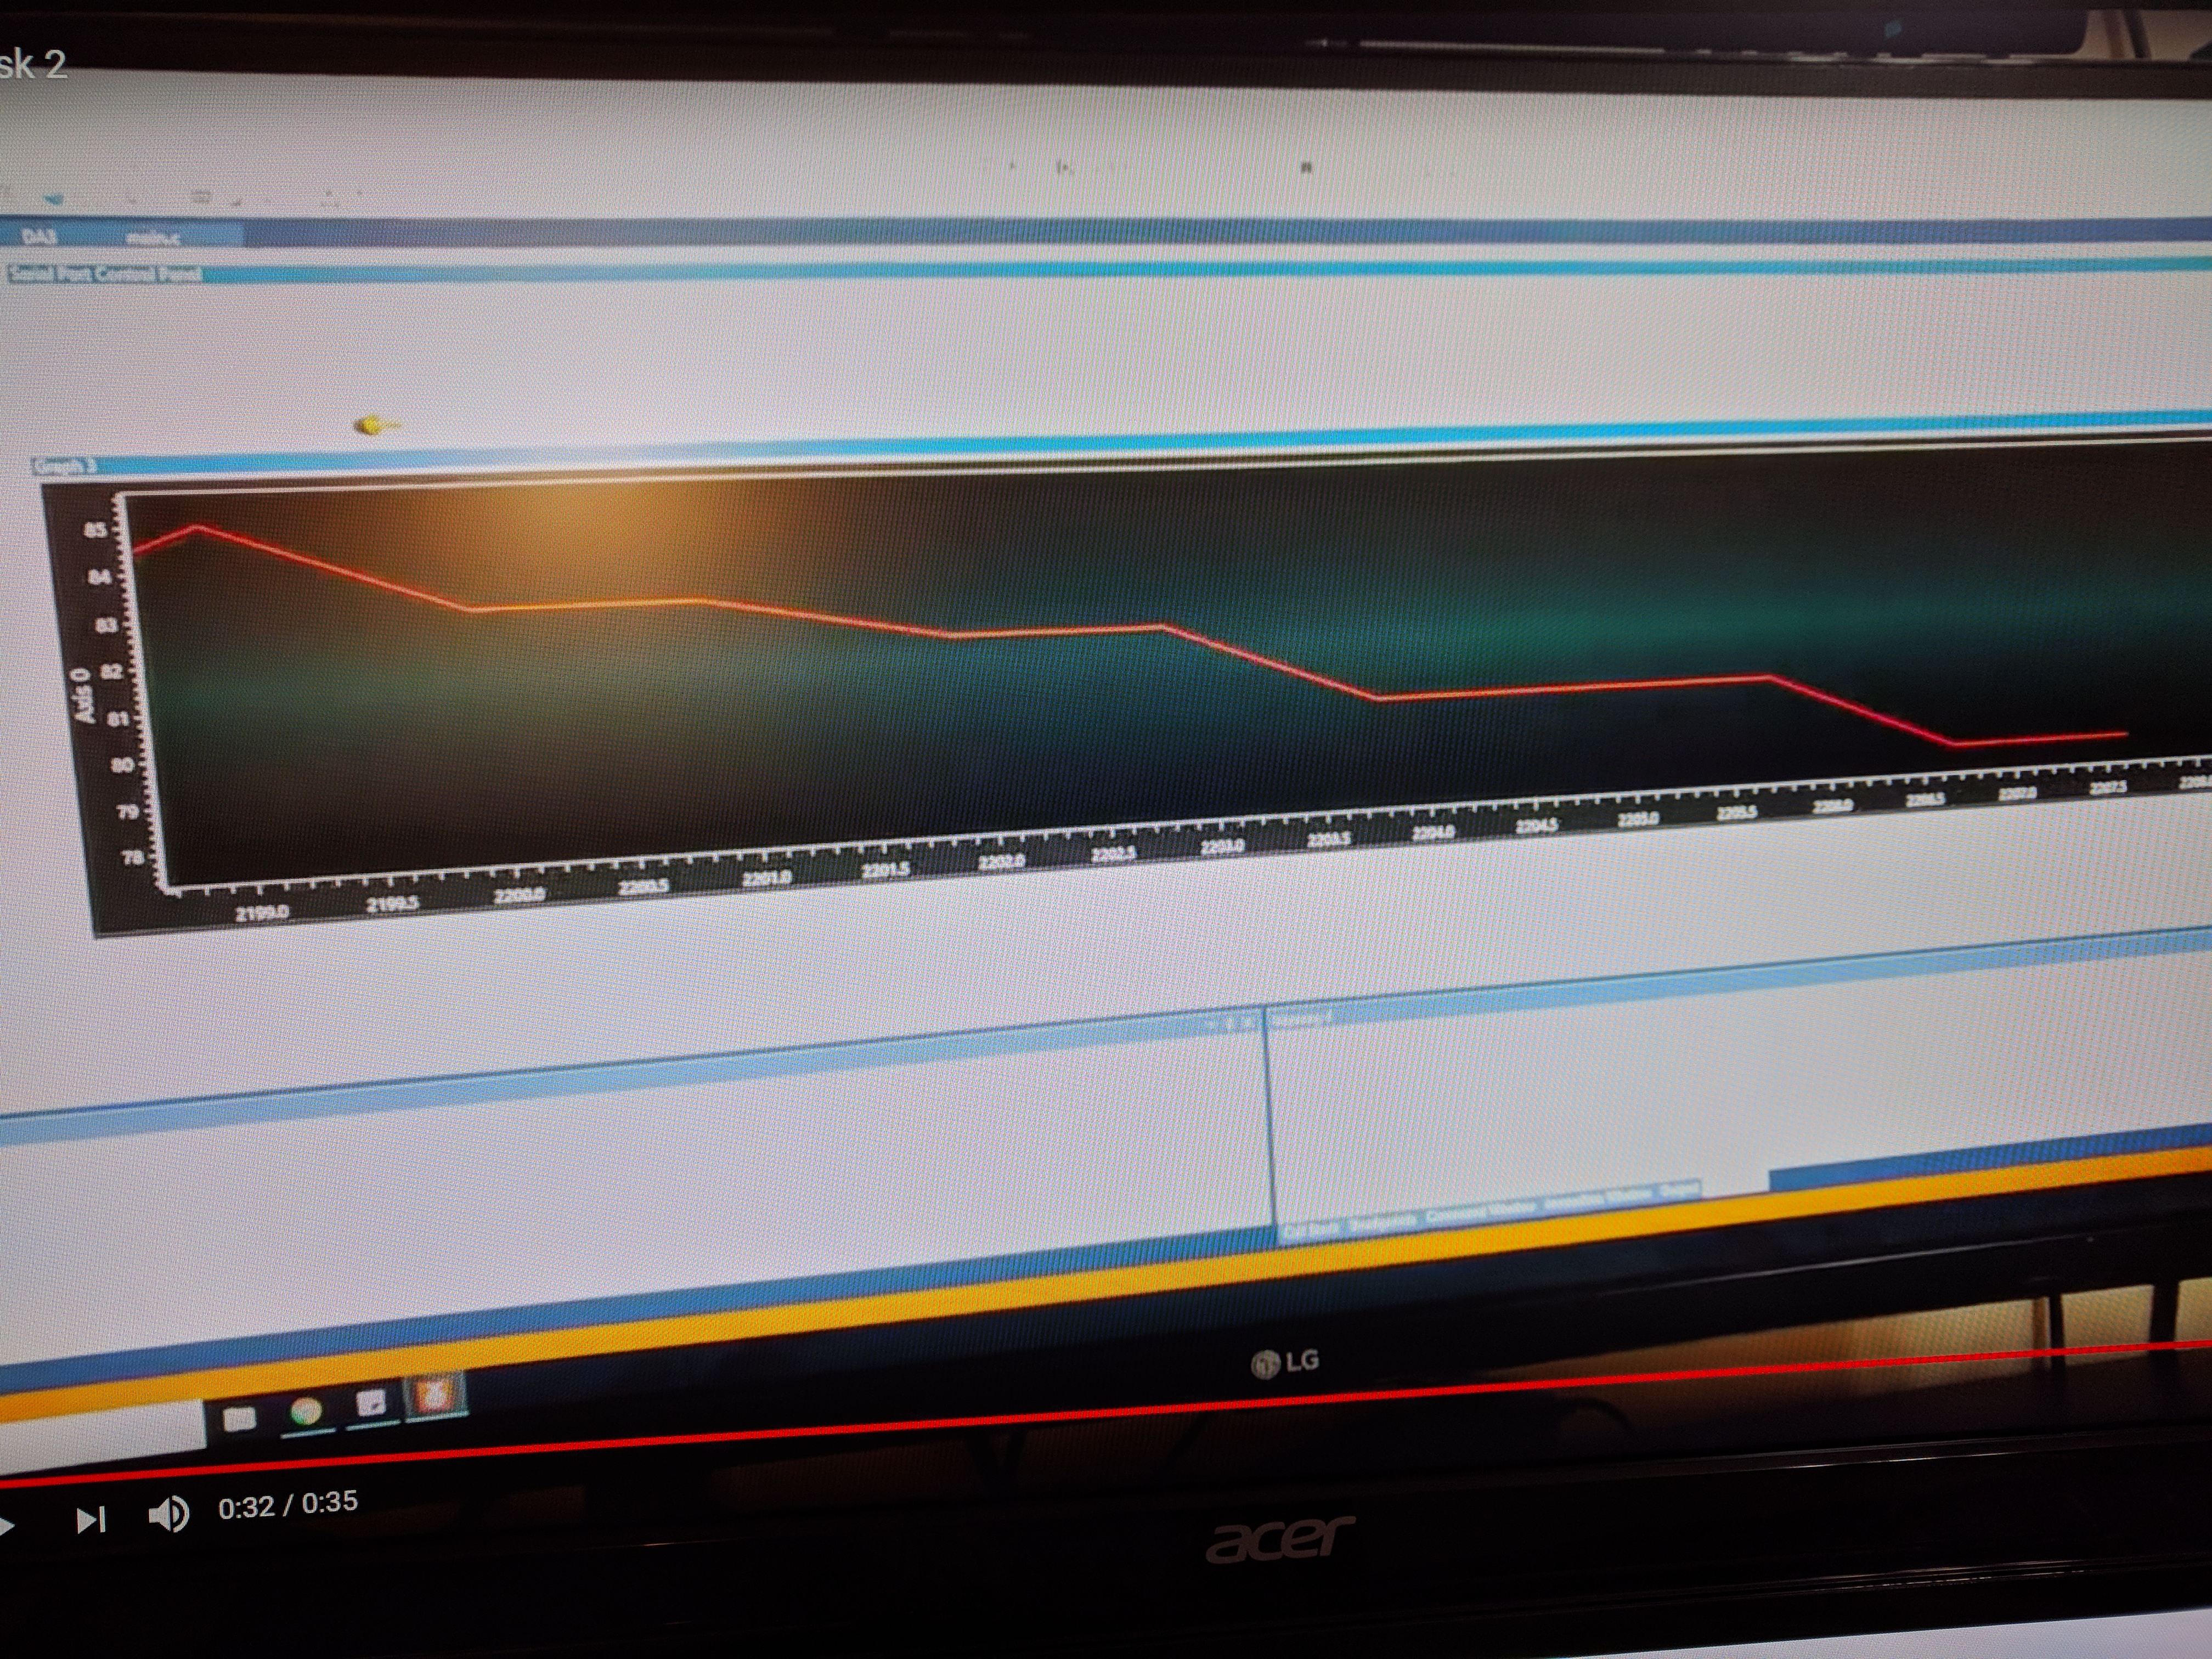

Figure : Temperature decreasing after holding onto the sensor (Data Visualizer)

1. **SCREENSHOT OF EACH DEMO (BOARD SETUP)**

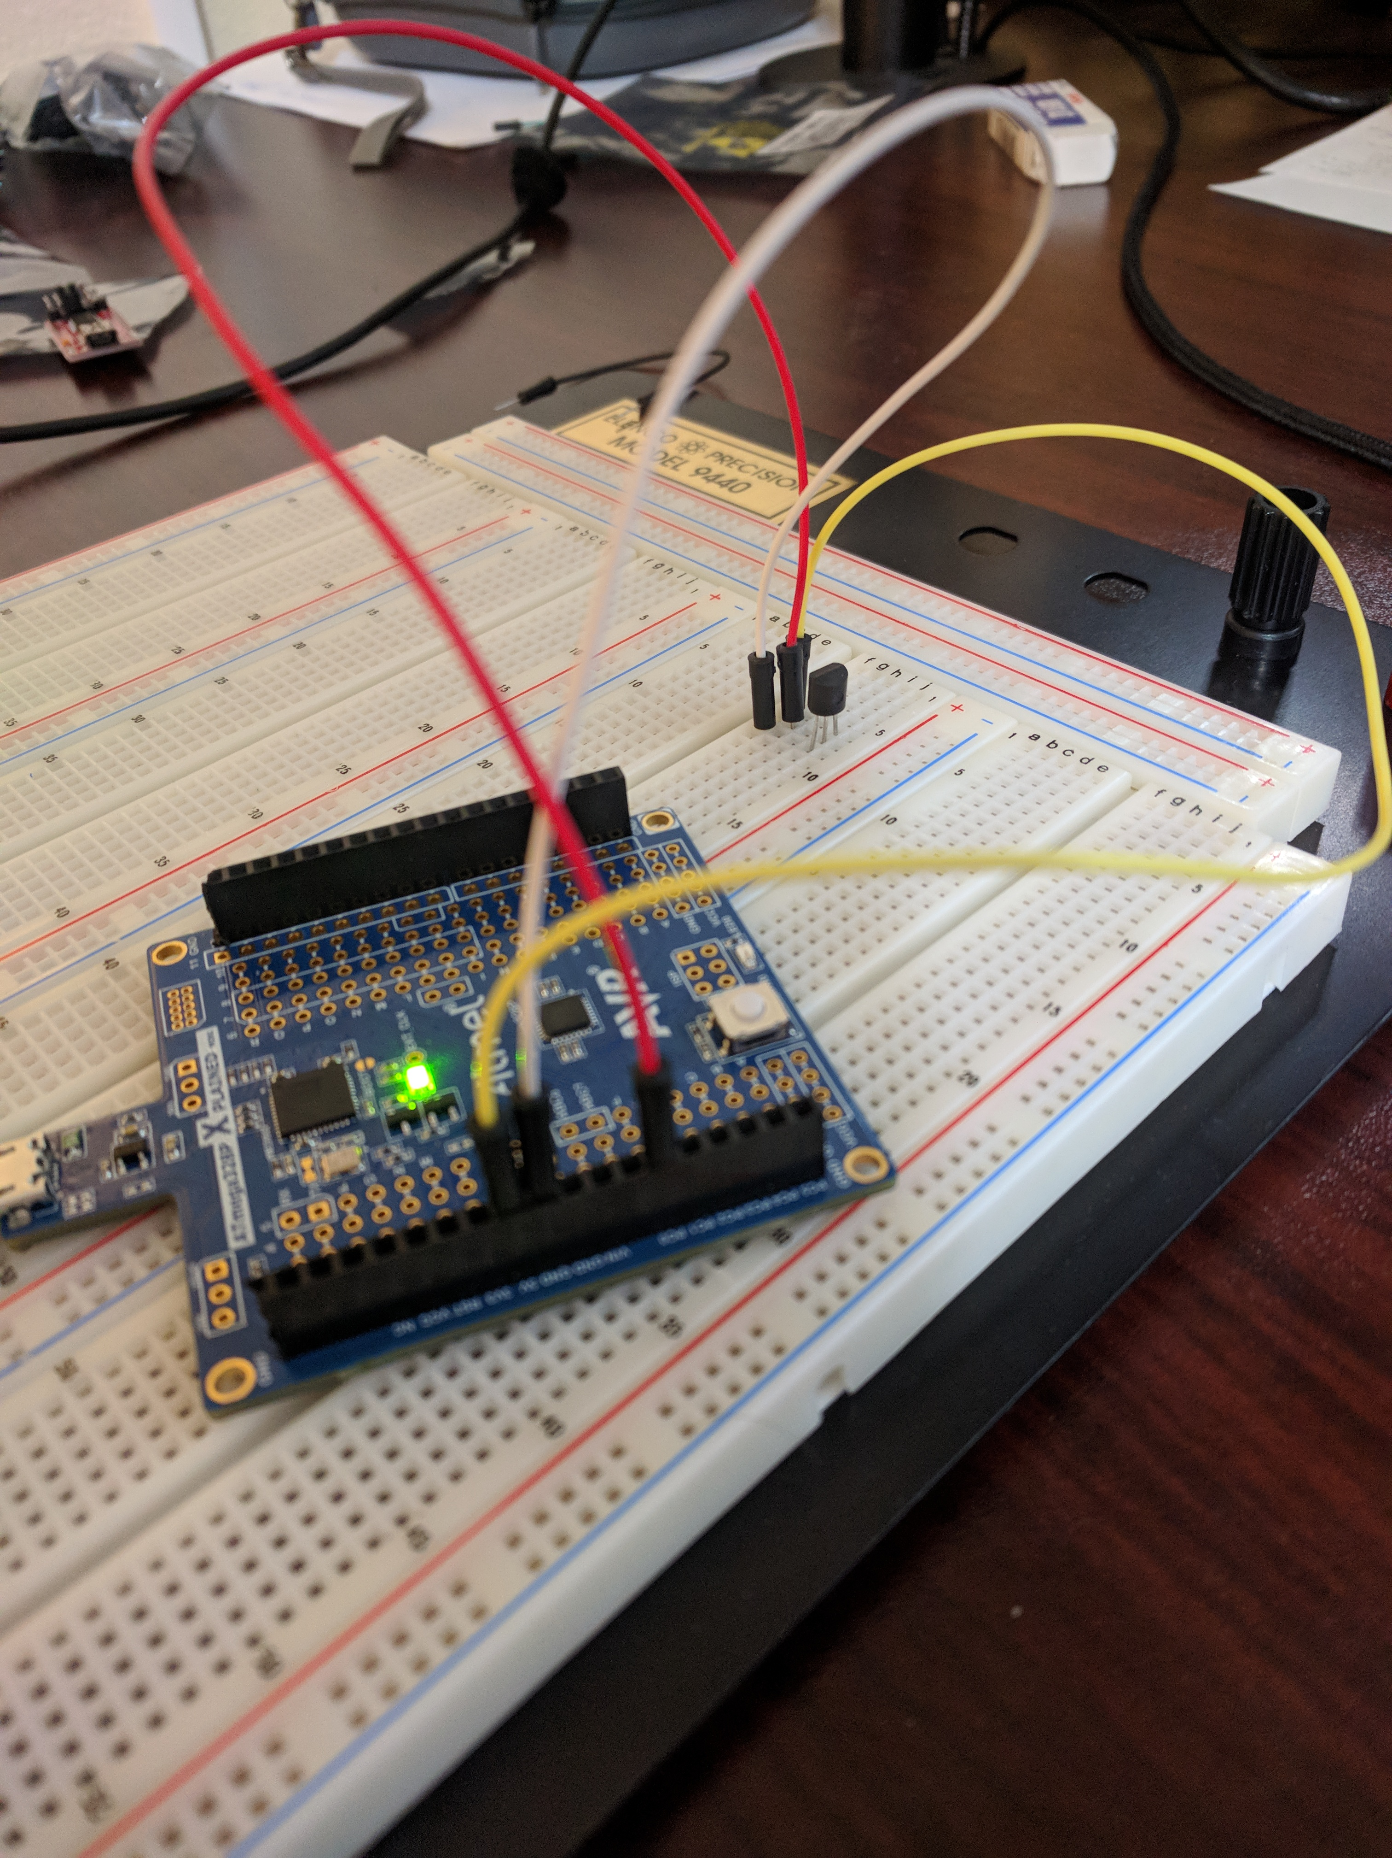

Figure 5: Side View of Setup

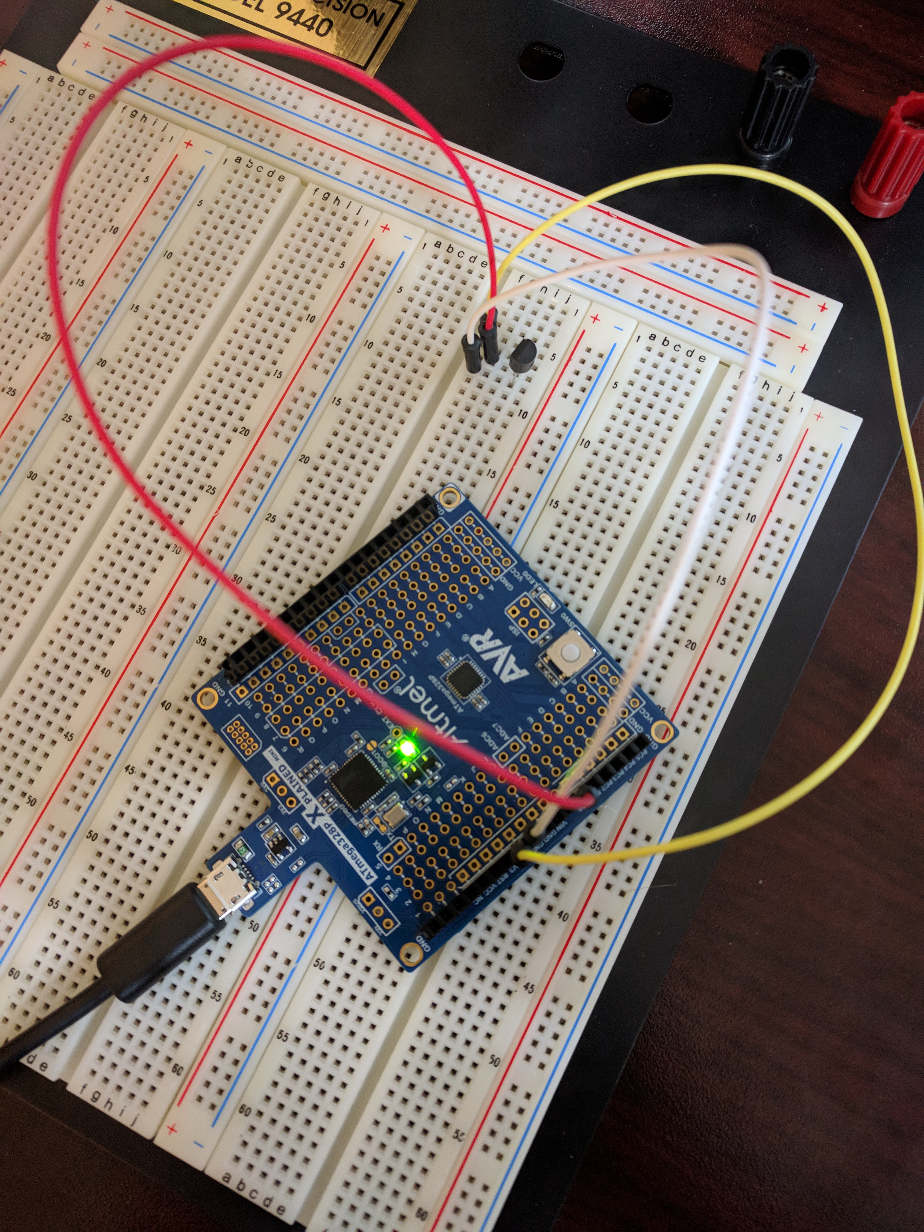

Figure 6: Top View of Setup

1. **VIDEO LINKS OF EACH DEMO**

Task 1: <https://www.youtube.com/watch?v=iblZ6KprCC8>

Task 2: <https://www.youtube.com/watch?v=Cs3bv4uKRVw>

**GITHUB LINK OF THIS DA**

**Student Academic Misconduct Policy**

<http://studentconduct.unlv.edu/misconduct/policy.html>

“This assignment submission is my own, original work”.

Trace Stewart